**TASK 1**

**Objective:** Write a program that display 10 integer numbers of following array.

|  |  |  |  |  |  |  |  |  |  |
| --- | --- | --- | --- | --- | --- | --- | --- | --- | --- |
| 3 | 4 | 5 | 7 | 8 | 9 | 12 | 15 | 16 | 100 |

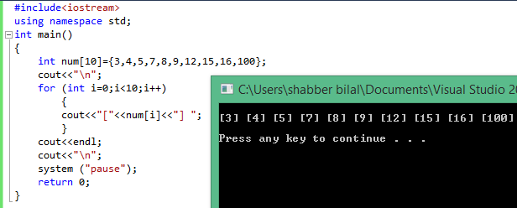

**TASK 2**

**Objective:** Write a C++ Program that takes 15 characters as input in array and print them.

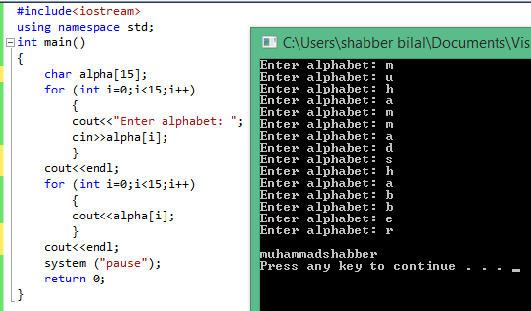

**TASK 3**

**Objective:** Write a C++ Program that takes 10 integers as input and print in reverse order.

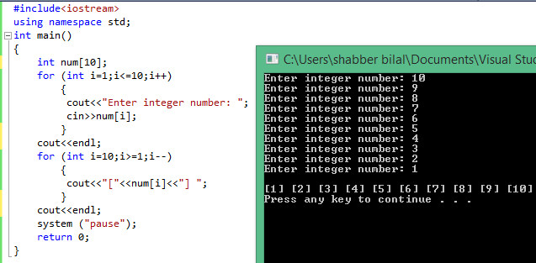

**TASK 4**

**Objective:** Write a program that takes 10 numbers as input and print their sum and average.

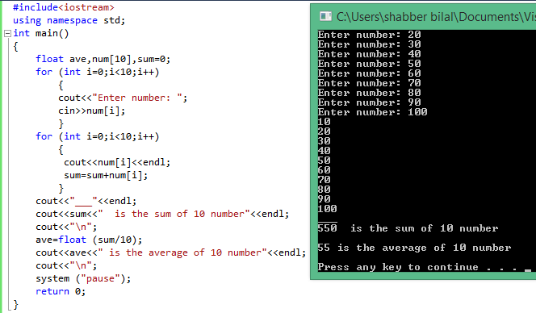

**TASK 5**

**Objective:** Write a C++ Program that takes 10 integers number as input and sort the array in ascending order.

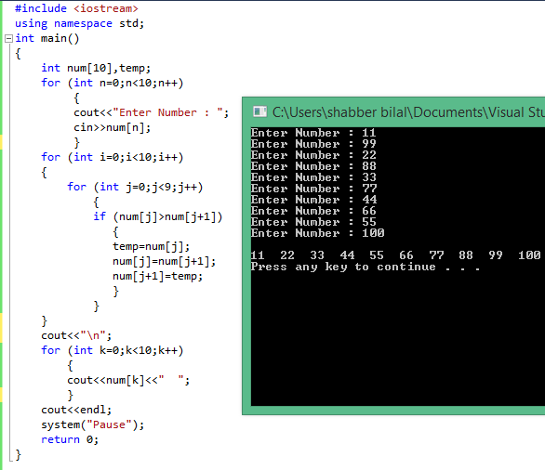

**TASK 6**

**Objective:** Write a program that prints 2x2 matrix of following values {2,2}{10,12}

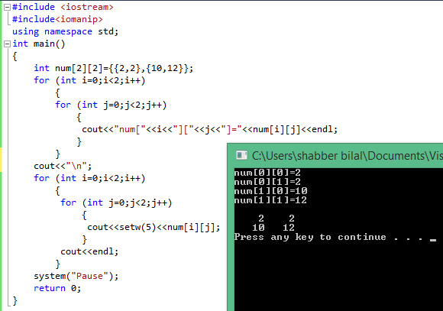

**TASK 7**

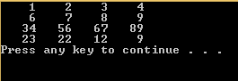**Objective:** Write a pogram that prints 4 x 4 matrix.

